**PC Master Race**

**A Multimedia Web Development Project**

**Stephen Joy – 300329148**

# INTRODUCTION

The **PC Master Race**, sometimes referred to by its original phrasing as the Glorious PC Gaming Master Race, is an internet subculture, internet community, and a tongue-in-cheek term of superiority for PC gaming used among gamers to compare PC gaming to console gaming.

In current parlance, the term is commonly used by PC enthusiasts both to describe themselves as a group, as well as their belief in the superiority of the PC platform in comparison to consoles, often citing features like more advanced graphics, higher framerates, free online play, wider variety of games, backwards compatibility, modifications, upgradability, customization, lower cost-over-time, open standards, multitasking, and performance. Popular imagery, discussion, and media referencing the term also commonly describes console users who prefer consoles over PCs as "console peasants" and people who play on PC as the "Glorious PC Gaming Master Race". (Source: [Wikipedia](https://en.wikipedia.org/wiki/PC_Master_Race))

This project aims to help those who are interested in joining this community by providing news on latest trends and development in the pc gaming environment from various reputed sources. It also provides a tool to prototype a gaming system with the price being provided for each component of the system. It shows you the estimated price on the components instead of the actual price, unfortunately, due to the current condition of the gaming industry (scalpers, chip shortages, price hikes, etc.).

# Sitemap

**Figure 1 - Site Map** shows the sitemap of this project. The website has four pages in total – Home, System Builder, About and Contact.

Figure 1 - Site Map

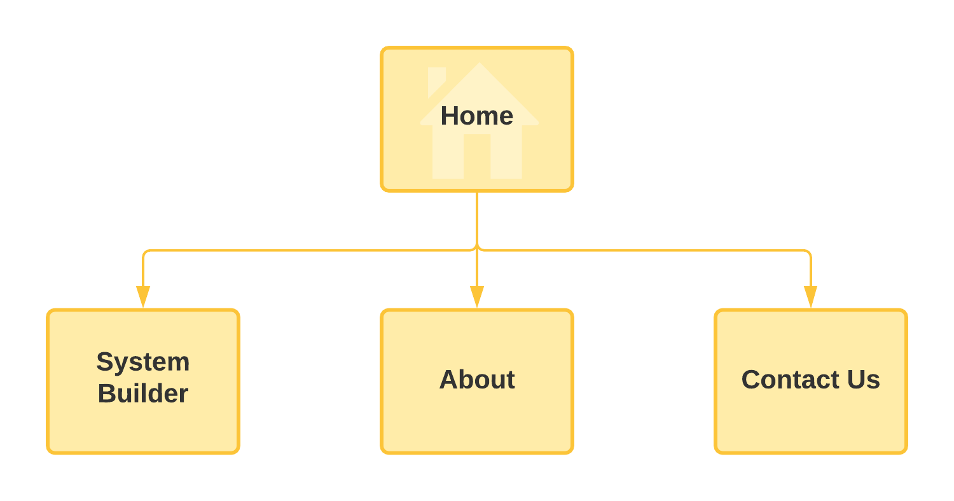

# Wire Frame

Wireframe diagrams provide the skeleton of the website or UI mock-ups by using simple lines and shapes to display the structure.

Figure 2 - Wireframe of Home page

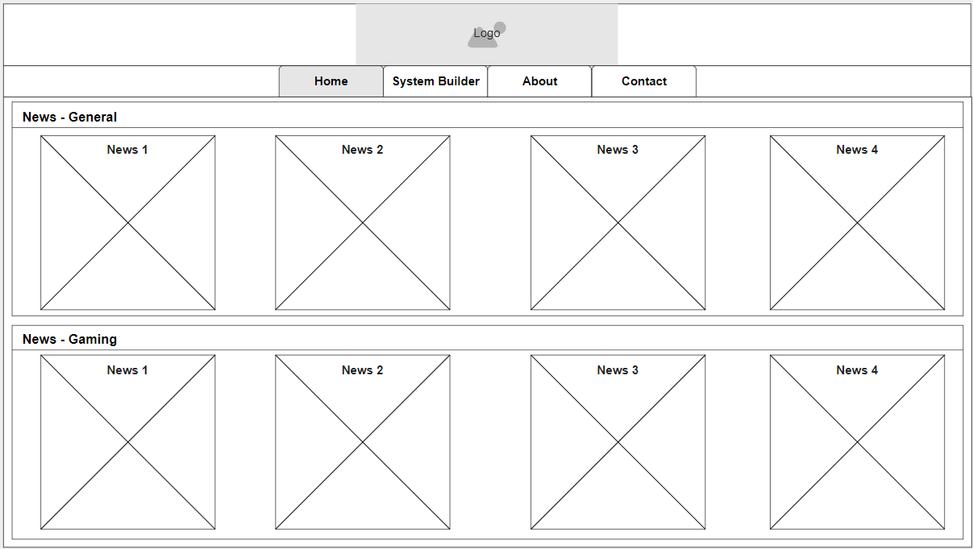

Figure 3 - Wireframe of System Builder page

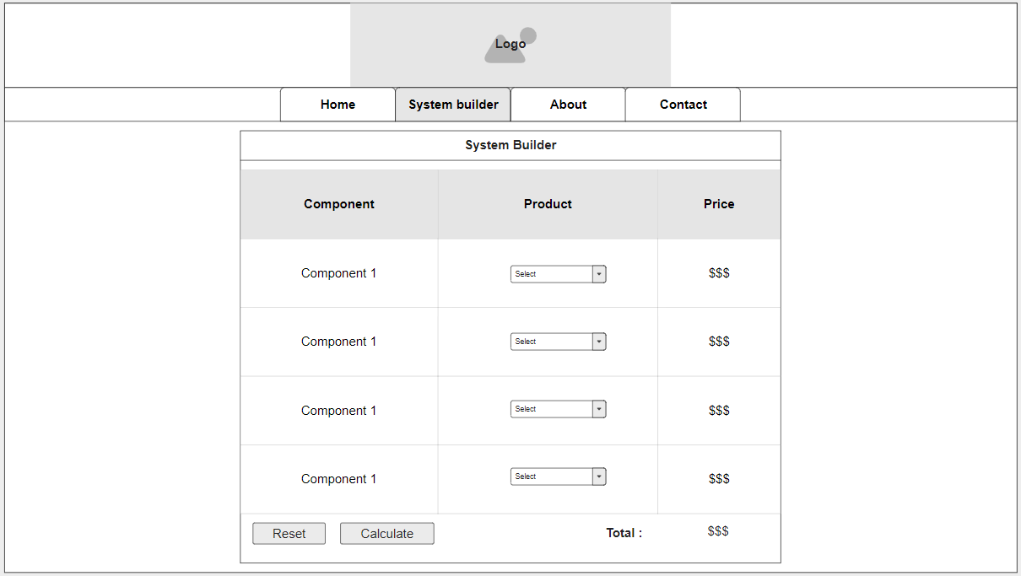

Figure 4 - Wireframe of About page

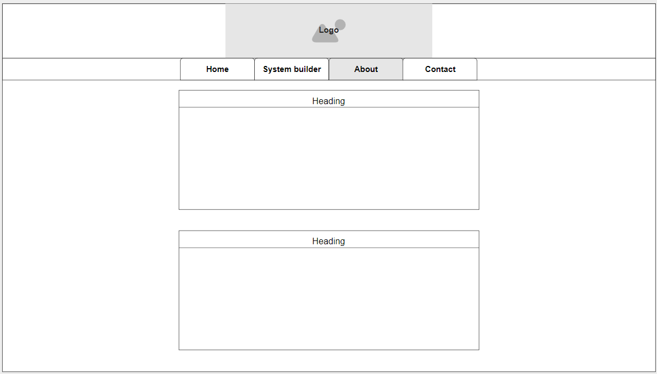

Figure 5 - Wireframe of Contact page

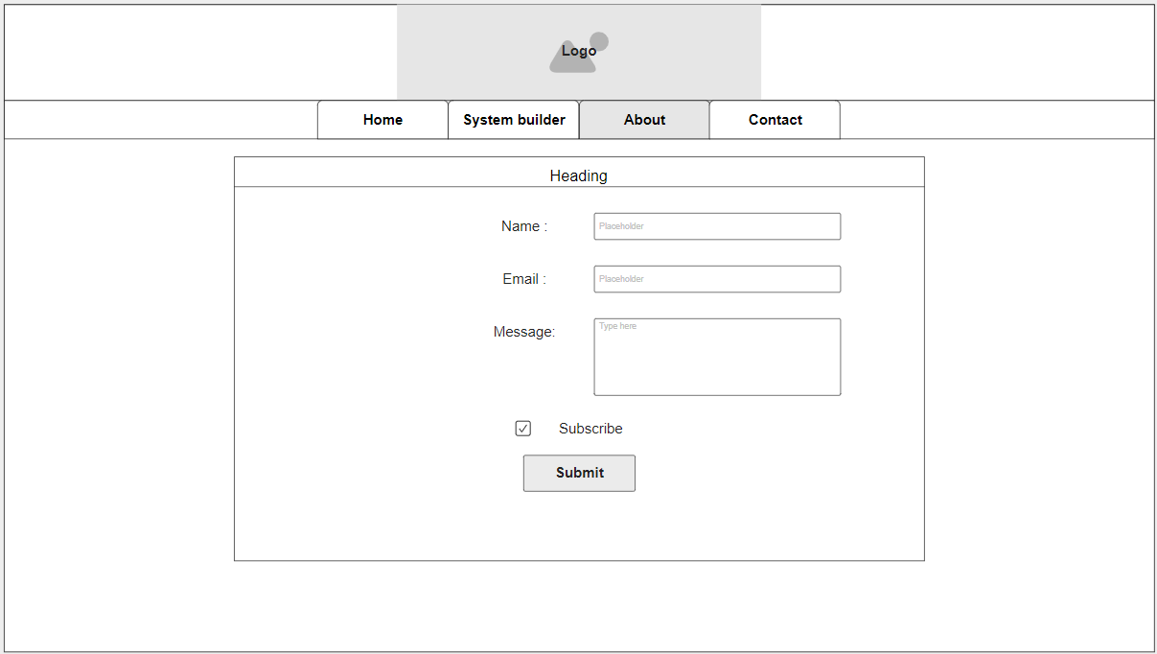

# References

## Home page

* Liu, Z. (2021, April 2). Nvidia Allegedly Increases GeForce GTX 1650 Supply To Fight GPU Shortage. Tom’s Hardware. <https://www.tomshardware.com/news/nvidia-allegedly-increases-geforce-rtx-1650-supply-gpu-shortage>
* Kan, M. (2021, April 1). Intel: Rocket Lake CPUs Were Green Lit Before Competition With AMD Became So Heated. PCMAG. <https://www.pcmag.com/news/intel-rocket-lake-cpus-were-green-lit-before-competition-with-amd-became>
* Hollister, S. (2021, March 23). The street prices of Nvidia and AMD GPUs are utterly out of control. The Verge. <https://www.theverge.com/2021/3/23/22345891/nvidia-amd-rtx-gpus-price-scalpers-ebay-graphics-cards>
* Lilly, P. (2021, April 2). This AMD Ryzen gaming PC with a GeForce RTX 3060 is available for $1,230. Pcgamer.

<https://www.pcgamer.com/this-amd-ryzen-gaming-pc-with-a-geforce-rtx-3060-is-available-for-dollar1230/>

* Morton, L. (2021, April 5). 2021 games: all the upcoming PC games to watch for. Pcgamer.

<https://www.pcgamer.com/new-games-2021/>

* Chalk, A. (2021, April 1). Call of Duty: Warzone’s attack helicopters are gone again after the invisibility glitch returns. Pcgamer. <https://www.pcgamer.com/call-of-duty-warzones-attack-helicopters-are-gone-again-after-the-invisibility-glitch-returns/>
* Alderson, A. (2021, March 31). CD Projekt announces a 2021 roadmap update for Cyberpunk 2077 and The Witcher series; Cyberpunk multiplayer delayed until at least 2022. Notebookcheck. <https://www.notebookcheck.net/CD-Projekt-announces-a-2021-roadmap-update-for-Cyberpunk-2077-and-The-Witcher-series-Cyberpunk-multiplayer-delayed-until-at-least-2022.530407.0.html>
* Park, M. (2021, April 3). Outriders proves, once again, that online-only singleplayer sucks. Pcgamer.

<https://www.pcgamer.com/outriders-proves-once-again-that-online-only-singleplayer-sucks/>

## System Builder page

Inspired by [PCPartPicker](https://pcpartpicker.com/list/)

## About page

Sources referred to :

* [PCMR - History](https://www.pcmasterrace.org/history)
* [PCMR - Guide](https://www.pcmasterrace.org/guide)